The ABC Family Case Study

Part I

The Abbot family was one of three branches of the family that owned and operated ABC Holdings, the leading U.S. manufacturer of industrial parts in the U.S. Fortune magazine ranked ABC Holdings one of the best companies to work for in America and the business was featured on the cover of Fortune magazine. ABC Holdings at its peak had 3,000 employees and was in 11 states around the U.S. and six foreign countries with about $500 million in sales. The 80-year-old family business was owned by nine family members actively involved in the business, spanning three generations. Elliot Abbot was an executive in the firm, and his oldest son, Ken Abbot, was employed in the business. Ken’s son, Peter, was the first of the third generation to work in the business. With the business thriving family received an attractive offer to sell it and decided to explore setting up a family office.
After the sale of ABC Holdings, the family committed in earnest to the setup, design, and implementation of a family office. Together, the three branches (Abbots, Canes, and Bonds) envisioned working together to create a family office structure to suit their needs and evaluated different service areas in which the family office might serve the family. Initially, they saw the opportunity to set up one structure to serve them all. However, as the three branches explored their interests, desires, and needs, they realized they were not all aligned on 1) the different services to be offered and 2) the different levels of service. Key family leaders also desired to perform various roles in the family office from being a part of hiring an executive to being considered for a management role themselves to outsourcing key advisory functions. For example, one family member desired to operate as the CEO and outsource the investment management to a third party, outsourced CIO; meanwhile, another family member desired to work collegially with a full-time CIO in-house. Other differences, including the desired level of service, as one family branch wanted to have more dedicated services and oversight related to property management, while another family branch had no need for such services. Another branch had set up many trusts, including generation skipping trusts (GSTs), and they therefore desired more focus and emphasis on fiduciary and custodial services. (See Exhibit 1 for the family genogram.)
Exhibit 1. ABC Family Genogram
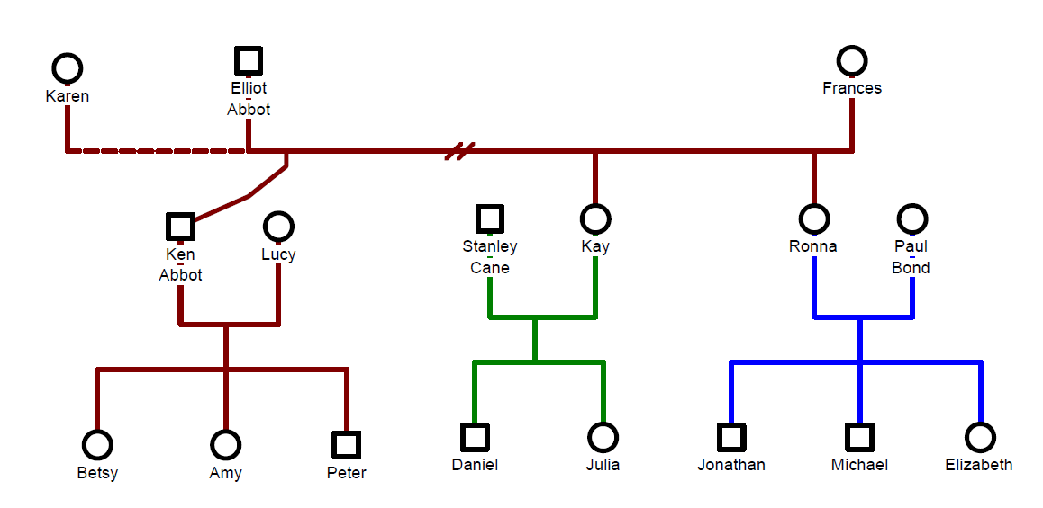
Another major consideration was scale and the associated buying power. Although all three branches had significant scale individually, did they each have enough to warrant a family office in their own right? The net proceeds of the sale gave shareholders approximately $750 million divided among the three branches equally. Yet, the question was also a function of cost and the control they desired to directly oversee their own assets. Did they want to potentially incur the additional incremental expense to operate autonomously from one another? Initial calculations estimated that a full-service family office (with assets between $50-$250 million) may have an internal cost of 50 basis points. For offices that opted to outsource their investment advisory to a third party, the external costs were approximately 70 basis points. All in, the research they were finding showed that the cost to operate a small office (under $250 million) fully built out could run anywhere from 60-100 basis points or .6%-1% of assets under management (AUM) per year based on their preliminary research. The family members researched the four different family office models in Exhibit 2.

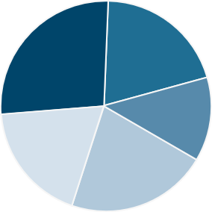
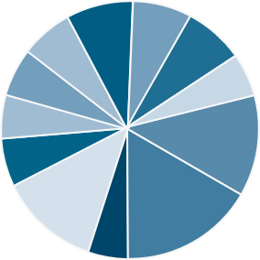
Exhibit 2. Family Office Structures
Virtual Family Office (Coordinator)
- Owner/Manager/Operator
- $50 150 million in assets
- 1-2 Generations
- Team of Trusted Outside Advisors
- One Family Member or Executive acts as Quarterback
- Small staff (1 or 2 people)
- Basic Reporting, minimal services
- Fully Outsourced
- May be a temporary solution.
- Formal Structure – LLC, S Corp, Coop
- Formal Mission Statement
- $250 + Million in Assets ($100 mm minimum)
- 3+ Generations
- Existed for 20+ years.
- Dedicated Staff
- Basic Systems /Reporting
- Mostly In-house and limited outsourced.
- For profit Business Structure
- No Founding Family
- $5+ Billion in Assets
- Lesser Concentration of Wealth
- Full Menu of Services Provided
- Greater Number of Clients
- Large Dedicated Staff
- Less Customization
- Complete Reporting
- All in-house
- Proprietary Products and/or open architecture
- Service agreements
- Multi-family Business Structure
- Alignment to Founding Family’s Mission Statement
- Min $500 million; typically, $1-2 billion in assets
- Fewer Number of Clients
- Dedicated Staff
- Complete Reporting
- In-house and Outsourced
- Open architecture
- Aligned vision and mission.

Traditional Single Client Family Office
Multi-Family Office (Closed End)
Multi-Client Family Office (Commercial)

Each branch was sensitive to different trade-offs with respect to control, customization, cost, and complexity. The Abbots were the most cost-averse; they required the least amount of communication, requesting only quarterly reports and desired basic family office services. The Abbots were curious if they might create an investment business with their wealth as the seed capital, however Ken was not sure if he could launch something like this on his own.
The Bonds, on the other hand, were the most complex in terms of services and assets, desiring fiduciary oversight, custodial services, financial planning, in-house CIO, personal services, oversight of household staff, and oversight with property management. The Bonds also wanted to see weekly manager reports, cash management reports, and aggregated monthly statements on all holdings and inter-family loans. The bonds were very private, wanted complete control and discretion. The Bonds felt it would be important to discuss as a family the mission of the office and its purpose to share with the other branches.
The Canes fell somewhere in the middle of the Abbots and Bonds. They were not sure if dedicated family services were needed nor custom reports, or a high frequency of communication. They did not feel as strongly about the need for direct oversight, as most were less interested in managing their investment oversight on a day-to-day basis. They decided to identify the core services and functions of the family office for their family branch and align them with their longer-term goals and vision. They wanted transparency and timely information but needed education on their holdings and what reports would show best what key metrics they desired to track. (See Exhibit 3. Family Office Services)
Exhibit 3. Family Office Services
Wealth Transfer
Property Management
Investment Management
Record Keeping
Lifestyle Planning
Diversification
Fiduciary
Estate Planning & Tax
Grant-making
Foundation Management
Trustee/Beneficiary Education
Insurance
Capital Sufficiency
Managing a Concentrated Stock Position
Risk Management
Gifting
Bill Pay/Cash Flow Management
Portfolio Construction
Operations & Compliance
Governance & Education

Part II

The three branches endeavored to work towards one common family office structure, hosting regular intimate calls and in-person family conversations. They weighed the pros and cons of each structure, considered how they would own and operate one structure and the customization and cost considerations that scale would provide them. Each branch prioritized their goals and discussed the “why” of their office. To arrive at these family office objectives, each branch of the family looked over lists of various family office functions and selected those that most applied to them. They did this process individually, then by family branch and ultimately in a large forum together. Subsequent refining conversations as well as input from outside experts and third-party research also helped to inform their planning. Additionally, each branch took into consideration the generational planning required for fourth and future generation family members (in addition to the planning needs for the first, second, and third generations). Intentional conversations were held over six to twelve months to organize the thoughts, intentions and to map out the services agreements, structures, and to understand each family as they considered their family office needs. Ultimately, they realized that they had very different goals, expectations, and service needs, which led them to amicably determine that three different kinds of family offices were needed. The Bond family wanted to create a full-service in-house family office, while the Canes desired a “hybrid” or outsourced single family office and the Abbots desired a “virtual” family office that primarily outsourced services through a multi-family office.
The Bonds
The Bonds identified the importance of establishing a full-service, family office which included all the services identified in Exhibit 3. The Bonds branch of the family hired a family office executive recruiter to help them interview candidates and eventually hire a chief financial officer and COO whose first task was to establish family office procedures and governance, determine lines of services and the organizational chart, human resource considerations and to draft an employee handbook. Next, they hired general counsel, as well as accountants, bookkeepers, and family service managers. The Bonds had their leadership set up a physical office location and then proceeded to build out the family office core services including – trust and partnership accounting, aggregated reporting, administration, document repository, investment management, tax, risk management, and wealth transfer planning, bill pay, and the requisite software.
Meanwhile the Bond family had many conversations with their leadership for the family office about how they wanted to approach their investment management. They asked imperative questions such as, “Do we want to pool our money? Are there advantages to pooling our money? Are we all comfortable with investing as a group?” The answer was, “yes” to all three questions. Next, they worked with independent investment consultants to help them think about portfolio construction and hiring a CIO. The Canes and Bonds agreed to pool their wealth and wanted active investment oversight with an internal CIO. As such, they formed new LLCs for various investment asset classes and started working with an executive recruiter to hire a top tier CIO. It took nearly 9 months to identify this candidate, and once she was hired, they went about an objective process with an RFP to identify and select investment managers. Designing an open-architecture investment program, the developed criteria based on an agreed upon list of investment characteristics related to risk, process, diligence, performance, track record, reputation, philosophy, and credibility for the RFP. Following the RFP process, the CIO narrowed the field of investment managers and interviewed them for ultimate selection and made recommendations to the family via their investment committee.
Next, the family office hired a chief technology officer (CTO) to custom-design their family office data management, cybersecurity, and IT infrastructure. In total, the family had to invest more aggressively to justify the overhead associated with the greater infrastructure demanded by their full-service office. The CTO also led the implementation of a new reporting software platform to support operational day-to-day management, manage the general ledger, reconcile accounts, and provide aggregated accounting capabilities, as well as the means to generate customize reports on-demand for each family member’s different reporting requests. The setup and costs associated with the first year of a de novo family office were around $4.5 million which included new software and service agreements. The next year’s operating cost to run their family office, including overhead for more than 15 family office staff, was around $3 to $3.5 million per year or roughly 65 basis points on their assets under management.

The Canes
The next branch, the Canes, established a hybrid family office with a small, lean team in-house, sharing the investment costs with the Bonds, and managing most of its services with third party providers. Their one employee was a former senior accountant at a nationally recognized firm and worked from her home office few days a week. Her roles spanned managing their accounting and financial affairs, their investment coordination, and their business affairs. Their second hire was a Chief of Staff who handled all family services requests, planning, concierge, and travel. The members of the family didn’t see a need to have an office, rather utilized a cloud-based data vault and reporting system through a professional services firm that also provided access to a virtual family office platform for accounting, reporting, data repository and task management. This allowed the family to plug in virtually and interface with the family office employees wherever they may be. They came up with a list of quarterly reports to be generated for the family, including family balance sheet, statement of net worth, cashflow statement, and investment performance reports by entity and in the aggregate. The family members operated out of their homes or from their individual separate offices. The Chief of Staff was supported through a network of top advisors, experts, and professional resources connected to each family member who helped defray the work and associated costs to perform tax, legal, administrative, and insurance/risk management tasks. The Canes family office structure was far less built out than the Bonds, and since they were able to participate in the pooled investment structures with the Bonds, they were able to defray costs. The Cane’s hybrid office costs approximately $600,000 per year to operate, not including the investment fees. That said, they paid higher fees to third parties to fill the gaps on tax, legal, accounting, financial planning, and professional advice that they outsourced.
The Abbots

The Abbots decided to initially operate a virtual family office. Their family office served three generations including Elliot, Elliot’s ex-wife, Ken and his wife, Ken’s three children (Betsy, Amy, and Peter) and their spouses, and Ken’s grandchildren. All six households were initially served by the virtual family office.

Ken was always looking for ways to defray costs. A year later, he approached his former non-family executive colleague Roger, with whom he had worked closely for many years at ABC Holdings, regarding the prospects of co-investing and/or sharing an office together. They determined that they had similar investment goals and philosophies and that they could divvy up the family office tasks and pool their collective wealth for co-investment purposes. They consulted outside counsel and were advised to set up a Registered Investment Advisor (RIA), since they were not related family members to fall under the single-family office exemption. Originally, they envisioned having one physical family office, but Roger retired from ABC Holdings moving his primary residence to the Bahamas for tax purposes. Thus, they could not agree on the same physical location for a single office, so they settled on establishing their own separate physical offices in addition to setting up systems that allowed them to operate virtually in the cloud. Ken and Roger researched investment managers and figured out how they were going to run the back-office part of the new operation. They both were now entering a new phase of their careers in investment management. In addition, their family office helped manage the Abbot’s family foundation (a private foundation), which is run by Ken’s wife, Lucy, who is also her family’s branch office administrator. The family hired a family office director and senior staff accountant to manage and reconcile the general ledger and an outside investment consultant to support Ken and Roger with the investment process, due diligence, and investment strategy. Ken and Roger initially were very bullish to be proactive leading their investment business. Working so closely together, Lucy and Ken started to regret working day-in and -out with one another and it took a toll on their marriage.
Despite family office operating improvements, there were still gaps with the compliance, investment oversight, and efforts to maintain efficiencies for the RIA. They did not feel they quite had the scale on the investment side, and Ken’s broader family often felt their needs were not getting sufficiently served due to the operational intensity and investment orientation of the office. However, the Abbot family values were frugality, minimalism, and practicality which translated into setting up a very basic office with nominal services and the associated lower expenses. After several years, Ken and Lucy were both tired and wanted to retire. Ken and Lucy determined that their family would be better served by joining a multi-family office and that the demands of maintaining an RIA in partnership with Roger were beyond the scope of their expertise. Sometimes Ken and Lucy wonder if they had simply identified an MFO in the first place and never went down the road with Roger. Where would they be now?
Conclusion
The relationship between the Bonds and the Canes grew stronger in part with their collaborative family office structures. The Abbots relished their independence but also felt strongly connected to the family tribe. Each summer, all the family branches still gather, selecting a different venue to celebrate their family roots and heritage. The family is still committed to fostering family togetherness, honoring their legacy in ABC Holdings, feeling connected by the shared past and their love for one another. They let go of the “baggage” from some of the family enterprise history, and relish in their ability to shape a preferred family experience for the rising generation who may not have experienced the good, bad, and ugly of the family business past. They stay connected through shared education programs that focus on family member well-being, stewarding wealth, becoming “financially fit”, developing entrepreneurs, team building and more. The family decided to collectively share the costs of family learning, as well as encouraging work-study opportunities, internships, and community service for the third and now fourth generation family members. This is how they are investing in their family capital to foster responsible ownership of their investment and financial capital for generations to come.
Notes:
__________________________________________________________________________________________________________________________________________________________________________________________________________________________________________________________________________________________________________________________________________________________________________________________________________________________________________________________________________________________________________________________________________________________________________________________________________________________________________________________________________________________________________________________________________________________________________________________________________________________________________________________________________________________________________________________________________________________________________________________________________________________________________________________________________________________________________

Appendix:
Single Family Office SWOT Analysis
Control
Customized, dedicated service
Privacy and anonymity
Alignment and integration
No SFO competition
Patient capital
Wealth preservation
Family first
Strengths
Weakness
Opportunities
Threats
Open architecture
Co-investments
First-class service
Collaboration
Sharing and streamlining costs
Peer-to-peer exchange
SFO best practice information and research
Attracting and retaining talent
Cost controls
Access to products and services
Operational efficiencies
Service level inadequacies
Bridging family continuity
Urgency toward strategic planning
Managing scope
Controlling costs
Compensation challenges
Generational mathematics
Family conflict
Succession planning
Keeping family on-board

Multi Family Office SWOT Analysis
Strengths
Weakness
Scale
Comprehensive services
Streamlined and efficient integration
Breadth of resources
Top talent and retention
Centralized data management
Client/Advisor load (+/-)
Institutionalize service offering
Access to products and services
Group-think
Customization or personalization
Bureaucracy

Opportunities
Threats
More for less
Learning curve
Open architecture
“One-stop shop”
Sharing costs for specialty services
Access to investment managers, products, and research
Thought leadership and innovation
Getting too big, too fast
Maintaining close relationships
Overpromising
Talent retention and turnover
Ownership and leadership alignment
Corporate culture

Appendix:
TO BUILD OR TO BUY
PROS BUILD
- Specialized, top-notch personnel
- Access to shared technology, techniques, or tools that might not be affordable or feasible on own
- Client best practice knowledge applied to guide the family
- Cleary-defined scope of services
- Higher turnover
- Outsourced staffing costs may be higher
- Family may be pressured to use the operators’ preferred methods
- Outsourced professionals may feel less accountable or committed
- Rollups or changes in ownership
CONS BUY
- Less agile in building capacity or downsizing
- Steep learning curves or resistance to change by staff
- Keeping current with technology and skills can be challenging - systems, financial investments, accounting, tax
- Updating and maintaining
PROS BUY
- Highest level of privacy and confidentiality
- Long-term personnel retention
- Personnel with insider knowledge
- Systems, policies, and procedures customized to family’s needs
- Greatest opportunity for hands-on family involvement
CONS BUILD

The ABC Family Office Case Study is a fictionalized case study loosely based on real families. Their names and identities have been obscured to protect their privacy.
The definition of a family office is a unique organization that is create to address the wealth management and/or enterprise needs of a family owner group providing tailored solutions in an integrated manner; functional areas may include administration, accounting, finance, investment, tax, legal, record-keeping, data management, planning, strategy, family capital, estate planning, wealth transfer, philanthropy, foundation management, governance, compliance, regulatory, security, education and legacy planning.

